Fitting P.E.T. connectors (PN CM3100-062) to RG59 cable
Peter Martin RFShop(UK) 17/04/24
sales@rfshop.co.uk
www.rfshop.co.uk
RG59 comes as single strand or multistrand. Either can be used. Single strand may fit into the connector pin slightly easier.
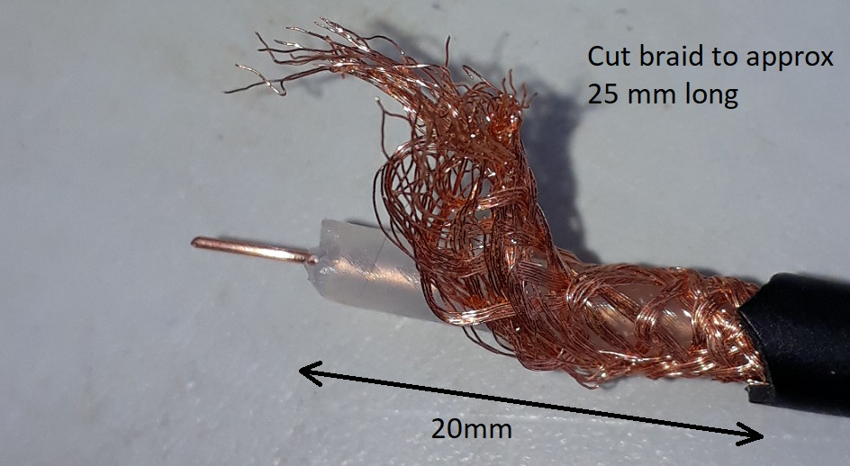
Trim the cable approx as shown. Make the braid slightly longer than the Teflon on the inner of the cable so that the end of the braid can be used to pull through the rest of it without it bunching as the cable is inserted into the body of the connector.
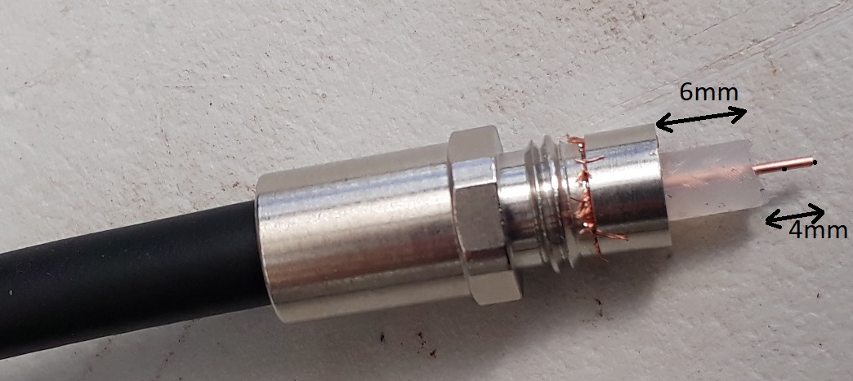
Insert the cable as shown, taking care to prevent the braid from bunching. Use excess braid as a “pull through”. Push on the thin circular metal clip and trim the braid back. Cut the Teflon and the inner wire to approx dimensions shown.
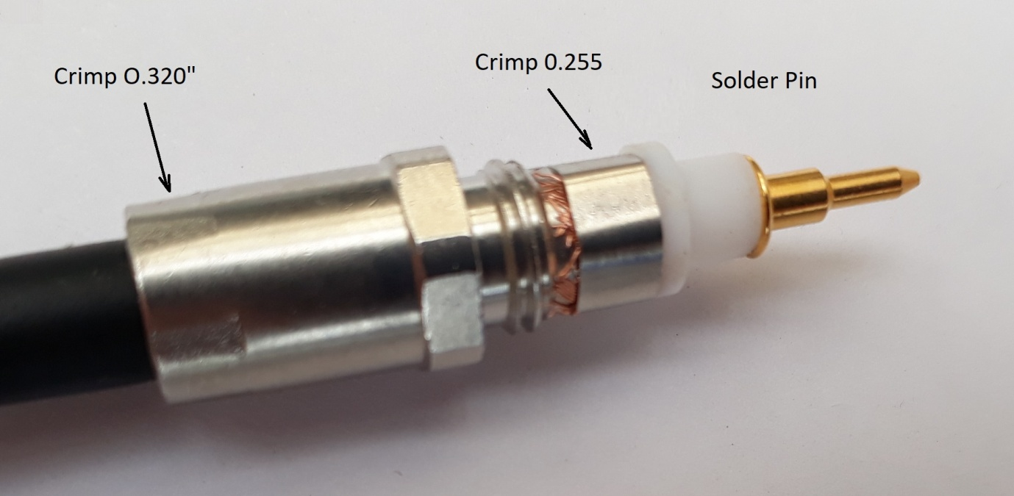
Crimp as above. The 0.320” crimp fixes the connector securely on to the cable.
Crimp die HT-336F (available from RFShop) is suitable for this purpose.
https://rfshop.co.uk/?product_cat=&s=crimp+tool&post_type=product
or put ‘crimp tool’ into search box: rfshop.co.uk
Fit the insulating spacer. Solder on the pin.
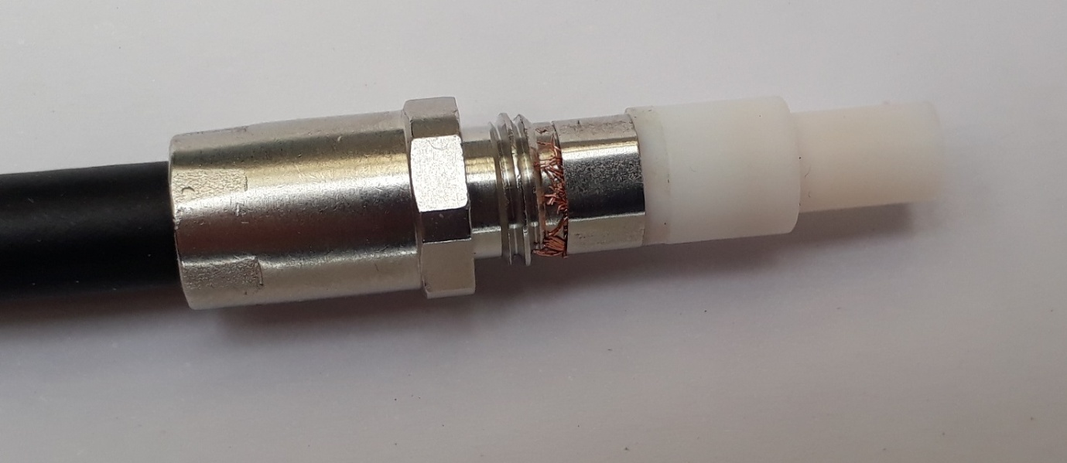
Fit second insulation spacer and insert into upper body of connector.
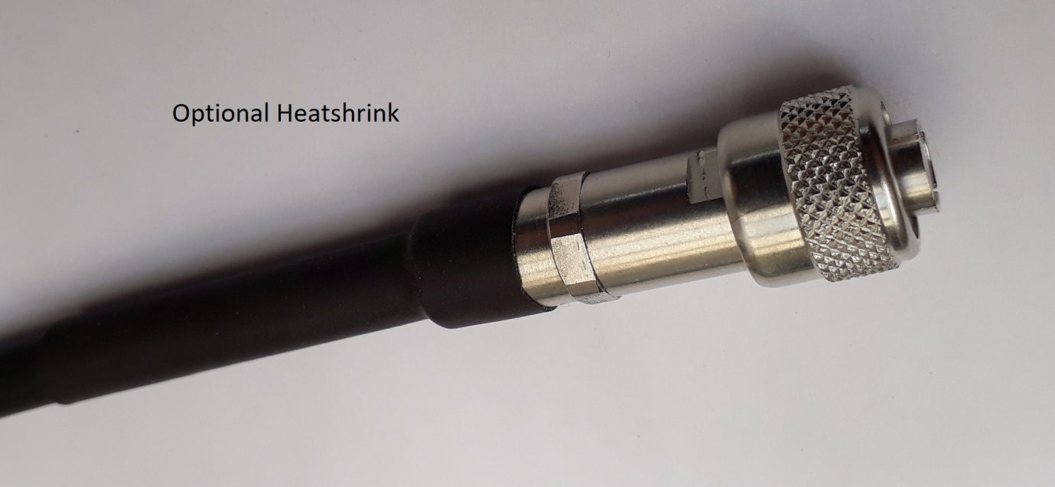
Finish the assembly by tightening the metal parts. A length of heatshrink tubing (8mm) can be added as an option.
If you’d prefer us to supply the completed cables just email for a quote.

